**UML DIAGRAMS**

ARCHITECTURE

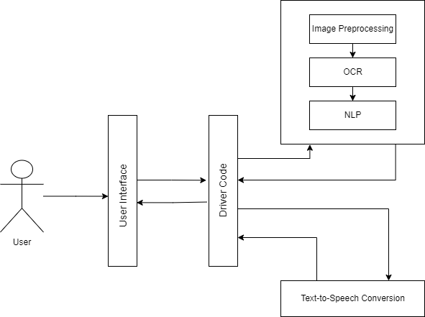

FLOWCHART

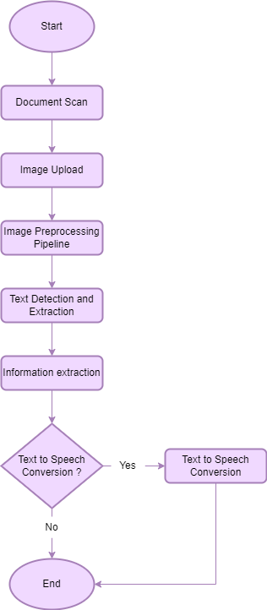

IMAGE PREPROCESSING PIPELINE FLOWCHART

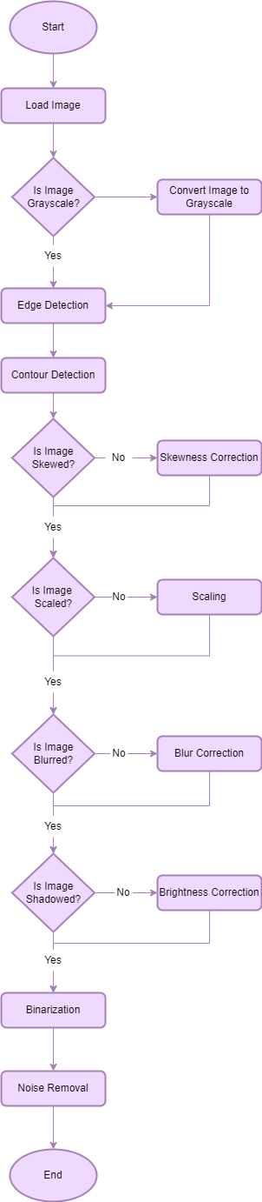

DATA FLOW DIAGRAM-CONTEXT LEVEL

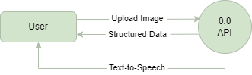

DATA FLOW DIAGRAM-LEVEL 1

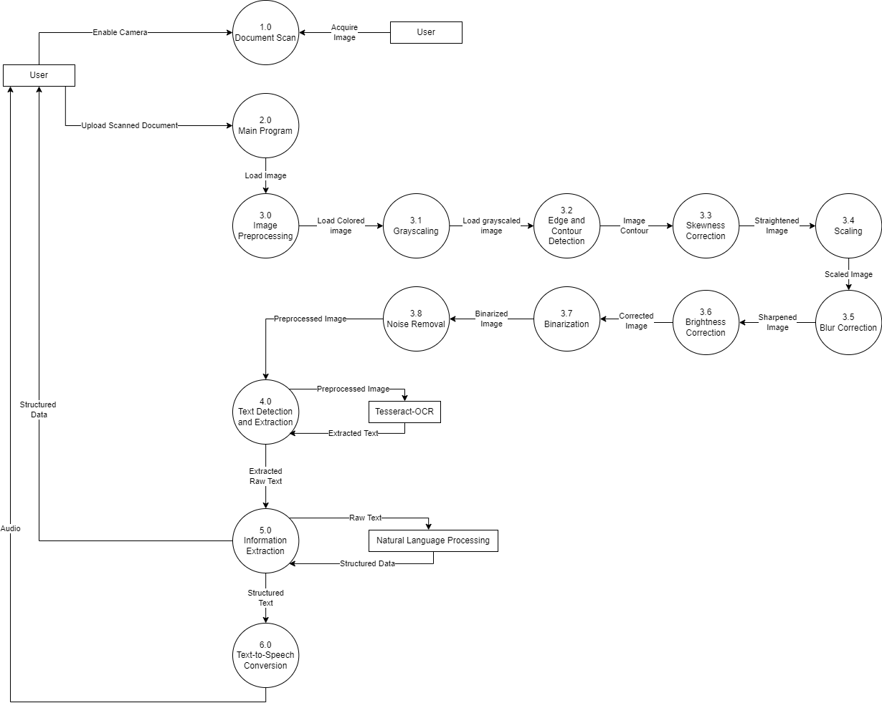

ENTITY-RELATIONSHIP DIAGRAM

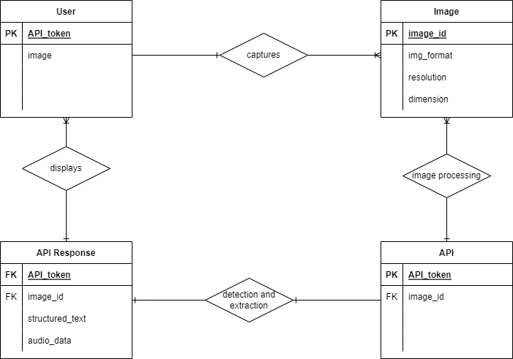

USE CASE DIAGRAM

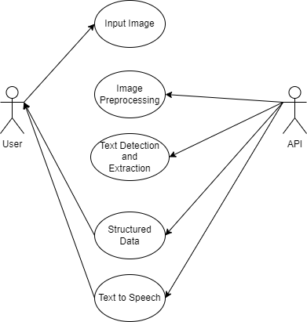

SEQUENCE DIAGRAM

